DESIGN AND IMPLEMENTATION OF STUDENT COMPLAINT SYSTEM FOR CKT-UTAS

KPELIM-ETME EMMANUEL YINNAWOL

C.K TEDAM UNIVERSITY OF TECHNOLOGY AND APPLIED SCIENCES

2025
DESIGN AND IMPLEMENTATION OF STUDENT COMPLAINT SYSTEM FOR CKT-UTAS
A PROJECT REPORT
Submitted by
KPELIM-ETME EMMANUEL YINNAWOL
In partial fulfilment for the award of the degree of
BACHELOR OF SCIENCE
in
SOFTWARE ENGINEERING

C.K TEDAM UNIVERSITY OF TECHNOLOGY AND APPLIED SCIENCES

AUGUST, 2025

DECLARATION
I, Kpelim-etme Emmanuel Yinnawol (20210410055), declare that this research report is my original work. It has not been submitted to any other university or higher institution of learning for any award.
Any academic document consulted for information is duly acknowledged and properly cited.
Signature ……………………… Date: …………………………
Kpelim-etme Emmanuel Yinnawol
(20210410055)

CERTIFICATION
I hereby declare that this project report “DESIGN AND IMPLEMENTATION OF STUDENT COMPLAINT SYSTEM FOR CKT-UTAS” is the authentic work of Kpelim-etme Emmanuel Yinnawol, who carried out this project under my supervision.
SUPERVISOR
MR. DOMINIC KWASI ADOM
Signature: ………………………………….
Date: ……………………………………….
HEAD OF DEPARTMENT
DR. PAULA ANINYIE WUMNAYA
(DEPARTMENTNT OF CYBER SECURITY AND COMPUTER ENGINEERING TECHNOLOGY)
Signature: ……………………………………………
Date: ……………………………………………….

ACKNOWLEDGMENT
I give my ultimate thanks to God Almighty for his sufficient grace, protection, and unmerited favor upon my life. I am ever grateful to my hard-working supervisor, Mr. Dominic Adom for his significant counseling and commitment to my growth and the success of this project. His suggestions were key in helping me complete this work. To my family, friends and loved ones, I owe them a huge gratitude for their unrelenting support. Furthermore, I would like to thank the school and staff of the Department of Cyber Security and Software Engineering for their assistance and guidance throughout this Process.

DEDICATION
I dedicate this work to God Almighty and my family, I thank God for his consistent protection, guidance and provision throughout this research study. I again thank my family for their continual support, love, and prayers throughout my academic studies. To my kind supervisor, thank you for all the support and love you have showed me during this research study. They have all been super support in all manner of ways when it comes to my academics, I say may the almighty God bless you all according to his riches and glory in heaven.

ABSTRACT
Systematic management of student grievances is very important for enhancing service delivery and guaranteeing tertiary institutions. Manual methods for resolving complaints are ineffective, time consuming, unstable and prone to data loss, causing student dissatisfaction. This research presents the design and implementation of student complaint system specifically in C. K. Tedam University of Technology and Applied Sciences. This outlines the steps in lodging, tracking, and resolving complaints online. The system was built using PHP and MySQL for the backend functionality and HTML, CSS, Bootstrap, and JavaScript for the frontend interface. It applies a client-server architecture, allowing students to submit complaints online and receive timely feedback, while administrators have the ability to prioritize, categorize and resolve cases effectively. User testing revealed improvements in resolution rate, accountability, and keeping of records as compared to the traditional methods. The system grants a reliable and clear platform for attending to student concerns, thereby improving institutional responsiveness and adding up to digital evolution in tertiary institution.

TABLE OF CONTENTS
CONTENTS PAGE
DECLARATION ii
CERTIFICATION iii
ACKNOWLEDGMENT iv
DEDICATION v
ABSTRACT vi
TABLE OF CONTENTS vii
LIST OF FIGURES ix
APPENDICES x
CHAPTER ONE 1
INTRODUCTION 1
Background of the Study 1
1.1 Statement of the Problem 2
1.2 Objectives of the Study 3
1.2.1 Main objective 3
1.2.2 Specific objectives 3
1.3 Significance of the Study 4
1.4 Scope of the Study 4
1.5 Limitation of the Study 4
1.6 Structure of Dissertation 5
CHAPTER TWO 6
LITERATURE REVIEW 6
2.1 Introduction 6
2.2 Foundational Perspective on Student Feedback and Complaints. 6
2.3 Evolution towards Digital and User-Centric Systems 7
2.4 Recent Advances and Technological Innovations 7
2.5 Contextual and Region-Specific Studies 8
2.5.1 Literature Mapping of Student Complaint System 8
2.6 Identified Gaps in the Literature 9
2.7 Implications for the Current Study 10
2.8 Conclusion 10
CHAPTER THREE 11
METHODOLOGY 11
3.0 Introduction 11
3.1 The Agile Software Development Methodology 11
3.2 Advantages of Agile Methodology 12
3.3 Justification for using Agile Methodology 13
3.4 Data Collection Methods 13
3.5 Brief Overview of the Existing System 14
3.6 Tools used for Development 14
3.7 Weakness in the Current Complaint System 14
3.8 Features of the proposed Agile system 15
3.9 Benefits of the New System 15
3.10 System Design Overview 15
3.11 Architectural and Structural Design 16
3.12 Detailed System Design 17
3.13 A Pseudocode for complaint submission and assignment. 18
CHAPTER FOUR 21
SYSTEM DESIGN AND IMPLEMENTATION 21
4.0 Introduction 21
4.1 System Implementation 21
4.2 Choice of Programming Languages Used and Reason 22
4.2.1 Hypertext Preprocessor (PHP). 22
4.2.2 Supporting Technologies 23
4.3 System Requirements 24
4.3.1 Hardware Requirements 25
4.3.2 Software Requirements 26
4.4 System Maintenance 26
4.5. Documentation and Discussion 28
4.5.1. The Login Page 28
4.5.2 The Dashboard 31
4.5.3 Feedback to Complaints Lodged 32
4.5.5 Department Page 34
CHAPTER FIVE 36
SUMMARY, RECOMMENDATION AND CONCLUSION 36
5.0 Summary 36
5.1 Conclusion 37
5.2 Recommendation 37
5.3. Limitations of the Study 38
REFERENCES 39
APPENDICES 42
Appendix A: Database Connection and Initialization 42
Appendix B: Complaint Submission Module 43
Appendix C: Complaint viewing Module 44
Appendix D: User profile and Setting 45
Appendix E: Feedback and Dashboard Modules 46

LIST OF TABLES
Table 4.1 Minimum Hardware Requirements Specifications ……………………. 30
Table 4.2 Minimum Software Requirements Specifications ………………………31

LIST OF FIGURES
Figure 2.1 A Litmap showing Web-based System Evolution …………………… 11
Figure 3.1 Agile Methodology Framework ……………………………………….14
Figure 3.2 Diagram Showing the Architectural Design of the System ………….. 20
Figure 3.3 Detailed Design of the System ……………………………………….. 21
Figure 3.4 Flowchart for Complaint Submission and Routing Process …………. 24
Figure 4.1 Login Page …………………………………………………………….35
Figure 4.2 Access Denial Page ………………………………………………….. 36
Figure 4.3 Student Signup Page ……………………………………………….... 37
Figure 4.4 Admin Dashboard …………………………………………………… 38
Figure 4.5 Student Dashboard ……………………………………………………39
Figure 4.6 Feedback Page ……………………………………………………….. 40
Figure 4.7 Settings Page ……………………………………………………….... 41
Figure 4.8 Department Page …………………………………………………….. 42

APPENDICES
Appendix A: Database Connection and Initialization ………………………….. 50
Appendix B: Complaint Submission Module ……………………………………. 51
Appendix C: Complaint viewing Module ……………………………………….. 52
Appendix D: User profile and Setting …………………………………………… 53
Appendix E: Feedback and Dashboard Modules ………………………………… 54
E.1: Student Dashboard …………………………………………………………. 54
E.2: Student Feedback Submission ………………………………………………. 54
E.3: Admin Feedback Management ……………………………………………… 55
E.4: Feedback Processing Endpoint ……………………………………………… 55

CHAPTER ONE

INTRODUCTION

Background of the Study
The integration of technology broadly across various aspects of human lives sketch out the need for corresponding digital transformation into all pre-existing manual operations which includes the educational institutions, business and the rest. These major improvements in technology is gradually moving society into an era of digitalization and thus moving away from manual processes. This gives all individuals at all levels additional capacity to access and process data, discarding the over dependence on computer specialist.
Among the many ways possible of applying digitalization, web-based student complaint system rises as one of the best way applying digital technology. This will help students in tertiary institutions become familiar with the use of technology, as the outside world is now moving into digitalization, this system will also help in making students lodge their complaints or grievances to school authorities and ensuring their complaints are been responded to by the school administrators accordingly which is the primary goal of the project.
Student complaint system in tertiary institutions is a well formulated process made to address student grievances and give out appropriate steps in resolving them. Its core objectives are to enhance student satisfaction, promote a positive learning environment and improve institutional accountability. Student complaints management systems have become an essential part of modern educational institutions to streamline the heading complaints (Al-Emran, M., & Shaalan, K., 2025).
Concerning tertiary institutions, handling student responses and complains is critical to fostering a productive and inclusive learning environment. Complaints of student mostly is based on existing issues in the administration, academics, welfare, and service delivery and thus any problem that comes any student’s way needs to be channeled to the administrators for swift and fast responds and resolution.
Traditionally, the method of lodging complaint or grievances by students was through Letters, SRC, and verbally thus visiting the offices of the appropriate persons to tell them what problem or challenge you are facing with regards to your academics in the institution. Which in most cases gets to their offices and meets their absence which in turn is time wastage and delays you from lodging complaints and getting solution. The handling of complaints lodged by students in universities as it is paper-based, informal, or bureaucratic, leading to delays, loss of information, and dissatisfaction among the students.
For a comprehensive complaint lodging by students and resolution by school administrators, there is the need to create an integrated web-based platform that can be simultaneously used to lodge complaints by students, and get responses as to the status of their complaints lodged. And also record all complaints lodged by students for tracking repeated complaints lodged by students mostly as time passes by. This functionality of the system will help the institution get to know and understand their students very well and get to address major problems in the institution to help foster smooth running of the institution with students being satisfied and not facing any challenge.
In response to the challenges and opportunities, this study primarily focuses on the design and implementation of a web-based student complaint system for tertiary institutions. The system will serve as a centralized platform for logging, tracking, and resolving student issues, ensuring fair treatment and timely responses and also keeping records of complaints lodged by students of the institution for future references.

1.1 Statement of the Problem
Unfortunately, the technology potential has not been fully realized in the educational sector, thus many tertiary institutions CKTUTAS inclusive are still relying on manual processes for handling student’s complaints and grievances. Which are ineffective, opaque with data integrity risks such as loose of data. Manual complaint handling processes are time-consuming, prone to data loss and lack transparency (Agyemang, G., & Gyan, K., 2021). In the same way, research in Ghana has showed that constrained embracement of digital solutions in tertiary institutions plays a role in the inefficiencies in administration and grievance resolution (Alhassan & Agyapong, 2022). The likelihood of student reporting may diminish when concerns about retribution, bureaucratic inefficiencies or lack of response mechanisms exist.
In addition, institutional administrators lack real-time data analytics to understand complaint trends and recurring issues.
The absence of an integrated system for managing complaints results in:
- Delays in resolutions
- Poor documentation and tracking of grievances
- Lack of accountability and transparency
- Minimal feedback to students
- Inefficient reporting and decision-making tools.
This study seeks to address these challenges by developing a digital student complaint management system tailored for tertiary schools.

1.2 Objectives of the Study

1.2.1 Main objective
The main objective of the study is to design and implement a student complaint system.

1.2.2 Specific objectives
The specific objectives of this study are as follows.
- To develop a secure web-based platform where students can lodge complaints online
- To implement a complaint tracking module for both students and administrators.
- To provide an administrative dashboard for managing, viewing and giving feedbacks on the progress of complaints lodged by students.
- To enable real-time notifications and updates to students regarding the status of their complaints
- To record and store complaints lodged by students for future references.

1.3 Significance of the Study
In the event of the above-mentioned faults and errors found in the manual system. It is believed that the introduction and integration of a web-based student complaint system will go a long way in changing the whole thing positively. It will empower students to voice out their concerns and grievances boldly without fear or delay.
Administrators will be provided a structured way to track and resolve issues efficiently and enhance a productive and inclusive learning environment for both them and the students. Again policy makers in the institution through this system will be offered insights into institutional weakness and service gaps thus areas in the institution that has problems and needs to be worked on. This also serves as a case study for software developers for developing user-focused academic support system.
Therefore, the study is important in fostering a productive and inclusive learning environment for both institutional administrators and students through the system standing as a solution to all the mentioned problems and challenges faced when it comes to students lodging complaints to the authorities. This is constant with UNESCO’s (2021) global report, which spotlights the importance of digital transformation in education to ensure equity, transparency and institutional accountability.

1.4 Scope of the Study
This study focuses on the design and implementation of a web-based student complaint system specifically for CKT-UTAS which lacks a digitalized and central medium for students of the institution to lodge complaints or grievances. It will cover login for both students and administrators, complaint submission by students, tracking status, viewing of complaints by administrators, and resolution. The system will only be accessible to students and administrative staff of CKT-UTAS, but not cover third party mediators or appeal processes.

1.5 Limitation of the Study
This research is to implement a web-based student complaint system for CKT-UTAS. Research of this nature needs much time to be able to gather reviews from students and administrators of the institution to help in understanding the requirements and the workflow in the institution and how to implement a fully functional system cross board and departments.
Never the less, the research is limited by web platforms and may not support mobile apps at the very state, but maybe in time to come. Also, the project is designed for internal use in the institution and may require modification for broader use. Security and privacy will be addressed at a basic level but not at enterprise-grade compliance standards (e.g., ISO 27001, GDPR).

1.6 Structure of Dissertation
This study is presented by five chapters. With chapter one focusing on introducing the research study, the scope of the study, its significance and organization of the research.
Chapter two talks about the literature review; both theoretical and empirical to the subject matter. Chapter three explains the methodology of the study, the system analysis and design and a brief description of the tools used in the study. Chapter four talks about the system results and discussion. The tech stack used, analyses modules and system requirements for implementing the system. It rounds up with chapter five, presenting a summary, recommendations and conclusions of the entire work.

CHAPTER TWO

LITERATURE REVIEW

2.1 Introduction
This chapter reviews existing studies related to the design and implementation of student complaint systems in tertiary institutions which in my case is CKT- UTAS. To provide clarity and coherence, the literature is reviewed through a combination of chronological sequencing and thematic categorization to capture the historical development of the topic “Design and implementation of student complaint system for CKT-UTAS” and identify the key areas of focus. It aims to answer core questions: What has been studied? What frameworks and technologies exist? What gaps remain? The review with the help of Litmap Visual analysis draws on foundational studies, digital transitions, recent innovations, regional insights, and practical challenges, providing a foundation for this project’s system design.

2.2 Foundational Perspective on Student Feedback and Complaints.
Early studies laid the groundwork for understanding the role and importance of student voice in tertiary institutions. Dolinsky (1994) and Coffield (1995) placed their focus on focused on establishing student voice mechanisms in tertiary institutions. They highlighted the need for a traceable feedback system as tools for enhancing institutional answerability and student satisfaction. They established the link between efficient complain resolution and institutional reputation, and also demonstrated how timely grievance handling impacts retention rates. Mann (2001) advanced this discussion by examining student engagement and resistance in academic settings, proposing that complaint systems should empower students rather than alienate them.
Rolfe (2002) spoke highly of the need for reflective practice within institutions, advocating the complaint data should be used for continuous improvement. Burke (2004) gave a critical lens on the university governance, stressing the importance of aligning complaint resolution processes with democratic values and public accountability.
These research works provide the ethical and conceptual foundation for complaint systems, establishing that such platforms are not just for resolution of logged complaint but also for institutional learning and improvement.

2.3 Evolution towards Digital and User-Centric Systems
AS digital technologies began to influence higher education management, the design of complaint system shifted from manual or paper-based models to web-based platforms. Schoefer (2008) discussed the principles of service recovery in educational settings, aligning with the core idea that resolving complaints effectively can improve trust and student loyalty.
Casado-Diaz (2009) explored user satisfaction metrics in academic support systems, which are critical for measuring the success of any complaint platform. Jackson (2009) and Millward (2015) contributed by exploring implementation frameworks and institutional readiness for digital solutions.
These studies collectively emphasize the need for web-based complaint systems to be user-friendly, intuitive and integrated with institutional workflows to enhance efficiency and responsiveness. This move corresponds with global expectations for higher education, choosing web-base and mobile-first platforms as transformative technologies in the field (Johnson, Becker, Cummins, & Estrada, 2016).
In Ghana, Sunyani Technical University implemented a web-based student complain system developed using PHP and MySQL to improve the reliability and efficiency of complaint management (Mohammed, Solomon and Nurideen, 2021). Similarly. Institutions in Northern Ghana introduced complaint systems with text-to-speech and speech-to-text features to increase accessibility and inclusivity for all students.

2.4 Recent Advances and Technological Innovations
Recent literature reviews highlight the growing emphasis on responsive and student-centered digital platforms. Which in my case, emphasizes on the need and importance for CKT-UTAS to adopt student-centered digital platforms (web-based) for complain resolution. Scott (2018) emphasized the importance of real-time communication and automation in complaint systems, aligning with modern students’ expectations for immediate feedback, status tracking, and system responsiveness. Moreover, Yilmaz (2020) emphasizes that the usability and full user experience of digital systems greatly decides student acceptance and long-term success. These findings are particularly relevant to this project, which aims to provide a streamlined, intuitive interface for submitting and monitoring complaints logged by students in the institution.
The focus, therefore, is on coming up with a standalone, web-based platform that give precedence to usability, speed of resolution, and ease of access. This approach reflects a practical and accessible direction suited to many tertiary institutions and of course CKT- UTAS inclusive which does not have such system.

2.5 Contextual and Region-Specific Studies
Tshotlego (2024) examined complaint systems in Botswana’s rural colleges, discovering challenges related to infrastructure, digital literacy, and cultural attitudes toward authority. Similarly, Phratama (2024) analyzed mobile-first solutions in Indonesian polytechnics, highlighting the need for resource aware and culturally sensitive systems. Kassem, R. & Dahab, M. (2018) realized that several web-based grievance systems have been developed globally, but most lack features for real-time tracking and feedback. These above studies give a track record of researches made on the proposed topic, thus highlighting the importance and impact it will bring when introduced in tertiary institutions.
In Ghana, the University of Ghana launched an Online Academic Complaint Platform in 2021, enabling students to log complaints electronically and receive feedback through coordinated academic channels. These practical examples demonstrate that web-based complaint systems are not only feasible but increasingly adopted in tertiary institutions in Ghana and across Africa. Alhassan and Agyapong (2022) also highlights that while digital platforms are been adopted in Ghana, a lot of higher institution still face challenges of accessibility, scalability, and institutional readiness.

2.5.1 Literature Mapping of Student Complaint System
To better understand the development of research on student complaint systems, a visual literature map was generated using Litmaps. The image below highlights key academic contributions arranged both chronologically (left to right) and by citation impact (bottom to top). Foundational studies, such as Dolinsky (1994), Mann (2001), and Burke (2004), form the early pillars of complaint system theory and student voice. As the field matured, more user focused and technological studies emerged, including Shcoefer (2008), Scott (2018), and recent context-specific works by Tshtelego (2024). This bibliometric overview supports the structured evolution outlined in this review and helps position the current study within a growing body of scholarly work focused on accountability, usability, and system innovation in tertiary education.

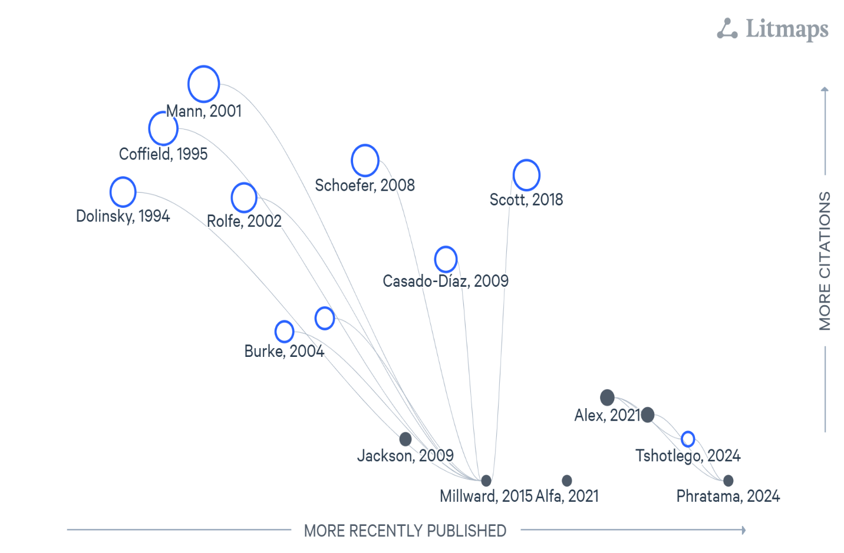
Figure 2.1: A Litmap showing web-based system evolution

2.6 Identified Gaps in the Literature
Regardless of the progress reviewed, several areas remain underexplored:
-Accessibility: Most platforms fail to address the needs of students with disabilities.
-Impact Evaluation: There is a lack of longitudinal studies on how complaint systems influence institutional policies or culture.
These gaps directly shape the innovation goals of this project, especially in proposing a system that is inclusive, easy to access and use, and policy-informing.

2.7 Implications for the Current Study
The literature provides a roadmap for system development. Foundational theories justify the need for a robust complaint platform. Digital evolution guides design choices such as web integration and user experience. Contextual studies remind us to design systems suitable for specific educational and cultural environments.
This project seeks to bridge the identified gaps by proposing a smart, user-centered complaint system tailored to tertiary institutions (CKT-UTAS), one that enhances accessibility, transparency, and institutional responsiveness. The proposed system integrates authentication for role-based dashboards, and complaint tracking for improve efficiency (Sommerville, I., 2016).

2.8 Conclusion
The literature review illustrates the evolution of student complaint systems from basic feedback mechanisms to intelligent, and integrated platforms. Foundational works emphasized ethical and institutional dimensions, while recent studies focus on user experience, technology, and context. However, there are still notable gaps that persist in the existing system, more specifically, in AI integration, emotional safety, and long-term evaluation. By addressing these gaps, this study aims to contribute a modern, adaptive, and student-centric complaint system for tertiary schools.

CHAPTER THREE

METHODOLOGY

3.0 Introduction
This chapter outlines the methodologies and tools utilized in the design and development of the “Student Complaint System for CKT-UTAS”. It details the structured approach followed throughout the project, given justification for the selected tools and techniques. By these detailed procedures, it gives way for researchers and project developers to share their systematic approaches to achieve the stated project objectives.
As defined by Aleksandr Georgievich Spirkin, methodology is a system of principles for organizing and structuring both practical and theoretical activities, essentially forming the theory of the system (Moshaq A., 2013). This definition demonstrates the essence of methodology in ensuring that research and development efforts are coherent, well organized and effective.
The Software Development Life Cycle (SDLC) guides the project from initial conception through to deployment and maintenance. With the numerous SDLC approaches which include Waterfall model, Prototype model, and Spiral model, the Agile methodology was applied in this project due to its features such us adaptability and focus on user feedback as the system is been built.

3.1 The Agile Software Development Methodology
The Agile software methodology highlights iterative development, continuous delivery, flexibility and collaboration. It simplifies the software project into small, manageable units call “sprints”. Typically lasting two to four weeks. Each sprints results in a functional component of the system, which is reviewed and improved upon in the next cycle of the system development.
Agile methodology has a continuous communication with stakeholders and end-users, making sure and being careful that final system meets user expectations and requirements and is able to adapt to changing environments. Agile encourages continuous improvement through regular retrospectives. Teams reflect on their processes and identify areas for improvement in each sprint. Agile also puts first delivering value to the customer which in this case is the students. Frequent customer (student) feedback and collaboration to help ensure the final product meets their needs and expectations. For such a system like a complaint management platform for students where user friendliness, responsiveness and student feedback are very critical Agile is ideal for the development.
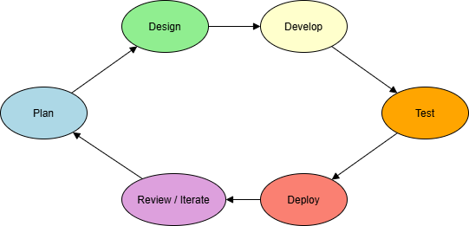
Figure 3.1 Agile methodology framework

3.2 Advantages of Agile Methodology
Agile methodology has advantages over the other methodologies, which makes it a better choice over the others for this system development. Some of these merits include;
- Encourages frequent user feedback
- Accommodates changing requirements during development
- Enables early delivery of functional components
- Enhanced collaboration and communication between developers and users
- Improves project transparency, visibility and tracking
- Higher overall project quality and user satisfaction

3.3 Justification for using Agile Methodology
- User – Centered Development: In Agile, there is frequent iteration cycles that makes sure student and admin feedback is swiftly incorporated, which is very important and necessary when it comes to a complaint system. This framework aligns with Yilmaz (2020), who elaborated that user-centered versions directly enhance the effectiveness and adoption of educational web platforms.
- Flexibility and Adaptability: Agile is highly adaptable and flexible thus supports mid – development changes, ideal for refining features based on stakeholder reviews.
- Risk Reduction/Control: With the continuous testing and reviews and each and every stage, Agile is able to reduce the likelihood of major failures late in the projects.
- Transparency: Stakeholders are involved in every sprint, improving trust and visibility.

3.4 Data Collection Methods
The collection of data in order to gather relevant user needs and system requirements, both primary and secondary data sources were utilized.
- Primary Data
- Digital Questionnaire: Google forms were created and distributed to students from various departments and levels here in CKT-UTAS. These surveys gathered data about students’ experiences with the existing complaint channels used and their expectation from a digital system.
- Observation was also made as to how administrative staff handled complaints made by students. Having a personal experience made me enthusiastic in finding a solution to the troubles that one had to go through before laying and concern and how long it took before receiving a feedback.
- Secondary Data
- Academic Journals and Textbooks: They helped establish best practices in software development and complaint management systems.
- Online Technical Resources: These also assisted in understanding modern approaches and architectural models to some of these problems.

3.5 Brief Overview of the Existing System
Presently, complaints in CKT-UTAS are submitted through informal channels such as going to the appropriate persons’ office and reporting verbally, through letters or SRC mediation. These channels of submitting complaints are inconsistent, untraceable, and often lack follow-up or resolution. With manual system, students with complaints that needs to be resolved would waste time to go to the appropriate staff office for their concern to be address but in the long run, on reaching their office sometimes meets their absence, also students will also put their concerns into letters and submit to the appropriate office but then letters might be lost by the staff resulting in delay in resolving the issue and the student having to go back again. Due to some of these students often feel discouraged and this is due to the absence of a structured feedback and tracking.

3.6 Tools used for Development
In the development of the “Student Complaint System for CKT-UTAS” the following tools and techniques were employed in order to come up with the system.

- Visual Studio Code: This is a user-friendly Integrated Development Environment (IDE) used for writing and debugging codes for the application.
- XAMPP: This is also providing the local server environment used in running the program locally. It includes Apache, PHP, and MYSQL.
- HTML, CSS (Bootstrap), JavaScript: These are used for building the frontend interface.
- Draw.io: Used to draw architectural diagrams and entity-relationship models.

3.7 Weakness in the Current Complaint System
- Lack of centralized or digital platform complaint submission system.
- Poor feedback resolution and mechanisms.
- No support for anonymity.
- High likelihood of information loss and delays.

3.8 Features of the proposed Agile system
The proposed new system is going to be a responsive, user – friendly web application that allows students to log complaints, monitor their status, and receive timely updates. Complaints are automatically routed to the appropriate administrative office, such as the IT Directorate, SRC, or departmental heads.
Key features include:
- Student registration and login
- Anonymous or identified complaint submission
- Category-based routing (IT Directorate, SRC, or departmental heads)
- Status tracking and resolution dashboard
- Admin account with response management tools
- SMS notification to students on updates

3.9 Benefits of the New System
Below are some of the benefits that comes with a web-based student complaint system for CKT-UTAS.
- Transparent complaint tracking
- Faster response and resolution times
- Role based access control for admins
- Secure, centralized, and searchable records.
- Accessible on mobile and desktop platforms.

3.10 System Design Overview
The system design serves as the foundation for building the student complaint management system and ensures all functional and non-functional requirements are carefully mapped to technical components. It outlines how different modules of the system interact and ensures the system is efficient, secure and scalable.
The system is designed following a three-tier architecture, consisting of:
- Presentation Layer (Frontend)
- Application Layer (Server Logic)
- Database Layer (Using MySQL).
The system was designed to be modular, allowing each component to be developed, tested, and improved independently during different Agile sprints. This modularity also allows for easier future updates or integration with the institutional system.

3.11 Architectural and Structural Design
The platform follows a three-tier architecture
- Client Layer: This is designed using HTML, Bootstrap, and JavaScript. It gives the user interface that students and staff interact with.
- Application Layer: This is also developed using PHP on Apache, this handles business logic, processing, and routing.
- Database Layer: Built with MySQL, it stores all system data including users, complaints, roles and logs.
This architecture ensures that each layer can be developed and maintained independently. It also enhances scalability, performance, and system security.

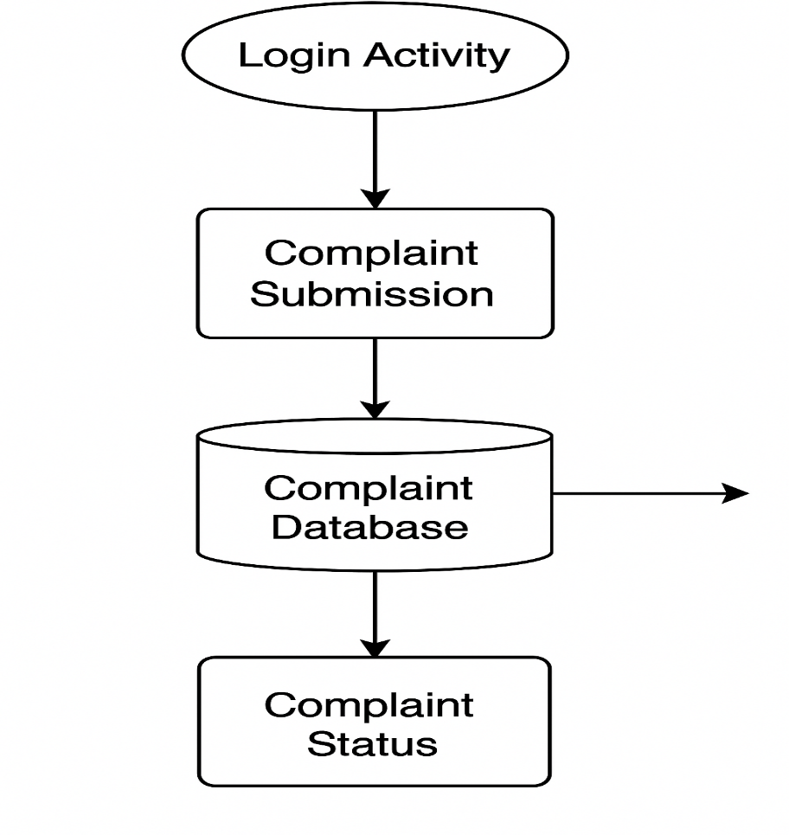
Figure 3.2 Diagram showing the architectural design of the proposed system.

3.12 Detailed System Design
Using Unified Modeling Language (UML), the system design includes;
- Use case Diagrams: showing different user roles (e.g., Student, Admin) and their interactions.
- Entity Relationship Diagram (ERD): Defining tables, fields, and relationships in the database.
- Activity Diagrams: Visualizing workflows like complaint submission and resolution.
These diagrams act as blueprints for the development team and help identify any inconsistencies before implementation.
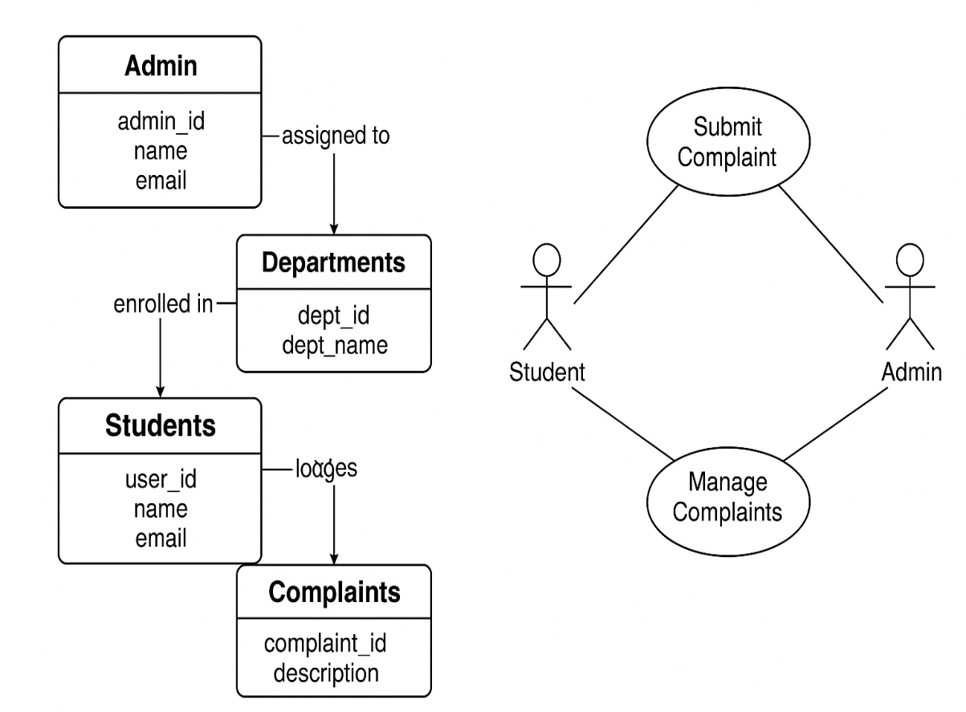
Figure 3.3 Detailed Design of the System.

3.13 A Pseudocode for complaint submission and assignment.
This part of the chapter presents a logical flow regarding how student complaints are being submitted and how they are been directed or routed to the appropriate administrator based on the department selected. The Pseudocode clearly shows major steps, including form validation, database insertion, and admin assignment. Pseudocode representation allows developers to understand system logic before actual coding (Sommerville, I., 2016). It also provides a high-level abstraction of the basack-end processing for complaint handling.

Pseudocode: Complaint Submission and Assignment Algorithm.
BEGIN

DISPLAY Complaint Submission Form
INPUT: subject, description, department, optional attachment

IF form is submitted THEN

VALIDATE all required fields
IF any required field is empty THEN
DISPLAY error: "Please complete all required fields"
EXIT
ENDIF

SANITIZE input data
GET current_student_id from session

SELECT department_selected from form
FIND admin_id WHERE department = department_selected IN admin_table

IF admin_id is found THEN
INSERT INTO complaints_table:
(student_id, admin_id, subject, description, status = 'Pending', timestamp)
DISPLAY success message: "Complaint submitted successfully"
ELSE
DISPLAY error: "No administrator assigned to this department"
ENDIF

ENDIF

END
Flowchart Diagram: The process of submitting a complaint
The below diagrams visually explain the logic in complaint submission by the students in the system. It begins from the form interaction, validates data, checks admin assignment, and then confirms submission success.

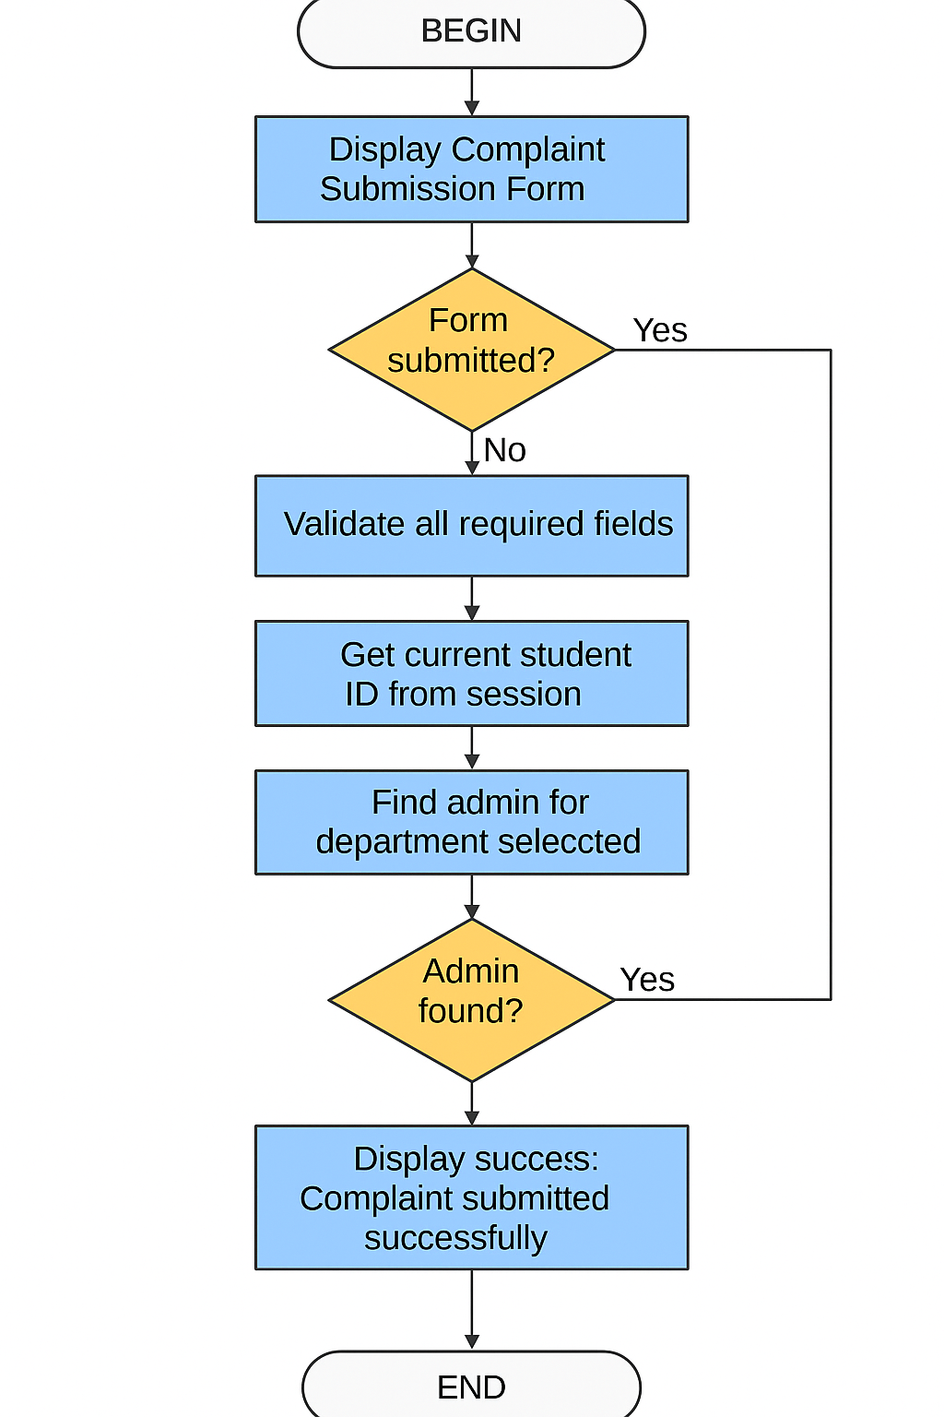
Figure 3.4: Flowchart showing the complaint submission and routing process.

CHAPTER FOUR

SYSTEM DESIGN AND IMPLEMENTATION

4.0 Introduction
This chapter is going to elaborate on the practical phase of the Student Complaint System, outlining out the proposed design was translated into a fully working system. It details the processes of system implementation, explaining the choice of the programming languages used, specifies type of hardware and software required, and gives information on system maintenance and documentation. The core reason is to bring to light how the system was developed, deployed and maintained for effective and efficient usage, in order to effectively do this, there is provision of screenshots to the working system at appropriate places to help illustrate the major functionalities, making sure there is a crystal-clear visual representation of the features discussed.

4.1 System Implementation
System implementation has to do with the step-by-step process of building of the system with reference to the design specifications presented in the previous chapter. In this project, the development process is carried out using a modular approach, with this approach each and every functional component was built and tested separately before being integrated into the whole system.
The frontend was developed using HTML, CSS, and Bootstrap for lay out and styling, while JavaScript gave interactivity. The backend was built using PHP for server-side logic, and MYSQL through XAMPP was also used for database management.
The major stages in the implementation process involved the following;
- Creation of the Database: A MYSQL database was designed with the name srccom_db to keep records of user information, complaint records, and admin feedback.
- Frontend Development: This is where user-friendly interfaces were created for complaint submission, tracking, and feedback viewing.
- Backend Development: PHP scripts were written to handle form submission, complaint processing, then database queries.
- Integration: The frontend and backend were connected through PHP to guarantee a stable and smooth communication with the database.
- Testing: As earlier stated, each unit was tested separately (Unit testing) and collectively (System testing) to ensure functionality and performance.
This is how the system works, first we have a login page with serves as an entry point for both users (students and administrators).

4.2 Choice of Programming Languages Used and Reason
The choosing of programming languages and tools for the development of the system was entirely based on how convenient they were for building web-based systems and their ease of deployment in local or online environments. Development of Complaint Management System requires a careful selection of programming languages and technologies to make sure that the system is efficient, maintainable, and scalable. With the vast number of programming languages available in world of software development, PHP (Hypertext Preprocessor) used as the primary programming language for the backend, while being supported by other tools and frameworks.

4.2.1 Hypertext Preprocessor (PHP).
PHP was chosen as the main programming language due to its large use in web development, open-source nature, and strong community backing. In software development, PHP has a lot of advantages over other programming languages when it comes to the backend. Below are some of the advantages that PHP has over the others;
- Easy integration with Databases;
Student complaint system relies greatly on databases as users (Students and Administrators) must store and retrieve records of complaints lodged and feedbacks, thus requires the integration of databases in its development. PHP gives a local support for MySQL, approving it as a great choice for the developing dynamic, and data-driven web applications. MySQLi and PDO (PHP Data Objects) usage verifies secure connections, protection against injection attacks, and prepared statement. This property of PHP has made it a better choice over the others.
- Robust Security Features;
Systems such as complaints systems prioritizes security very high. PHP contains in-built functionalities that are used for handling data purification, user session handling, and verification of users. Password hashing (using password_hash() and password_verify( )) and secure form handling are precautions that were added into the system to ensure user information is safe.
- Multi-platform support:
PHP applications has the capable to run smoothly across different platforms such as Windows, Linux, and macOS. With regards to the student complaint system which has the tendency to be hosted across different environments, the use of PHP gives an assured flexibility in deployment.
- Economic friendliness:
PHP is an open-source, and therefore there are no licensing costs involved. Making it a great choice for academic institutions with very limited budgets who might adopt the system in the near future.
4.2.2 Supporting Technologies
Complementary technologies were adopted to aid in the development of the Student Complaint system. These technologies are;
- HTML: This is the backbone of any website, it gives the structure of the page, while CSS takes care of the style, and JavaScript adds interactivity. This is a technology that Ensures that the webpage is structured as expected.
- CSS: Cascading Style Sheets (CSS) is used to style and format HTML elements, it determines how a webpage appears that is in terms of color, fonts, layout, spacing etc. It separates content (HTML) from presentation (Design).
- Bootstrap: A frontend CSS framework used to design responsive and mobile-first websites faster. This is a framework that was established by twitter (Open-Source Project) that provides pre-built CSS classes and JavaScript components so developers can build responsive components, that minimizes development time while a modern look is maintained.
- JavaScript: This is a scripting/programming language used to make web pages interactive and dynamic. It focuses on enabling the client-side interactivity, such as dynamic form validation and interactive user dashboards.
- MySQL (via XAMPP): MySQL is also an open-source Relational Database Management System (RDMS) which makes use of SQL (Structured Query Language) to store, manage, and retrieve data. Its primary objective is to store structured data in tables (rows and columns) and supports relationships between tables.
- XAMPP: It is a free and open-source multi-platform software package that gives a local server environment for the development of web applications. XAMPP provides an all-in-one local server environment, making development, testing, and deployment easier for software developers.
HTML, CSS JavaScript, and Bootstrap which are supporting technologies to PHP were chosen for their compatibility and ease of deployment on XAMPP servers (Welling, L., & Thomson, L., 2017). They are open-source, well documented, and have the ability of running smoothly on low-cost hardware, making them a very good choice for a tertiary school setting. Implementing these popular technologies is steady with worldwide trends in tertiary institutions focusing on scalable, widely supported web development tools (Johnson et al., 2016).

4.3 System Requirements
This is one of the most important elements that have to be considered when developing a web-based application. Every web application has specific hardware and software components that it requires in order to run seamlessly. Student Complaint System which is web-based application is not an exception, thus the need for us to consider the requirements of the system both hardware components and software components.

4.3.1 Hardware Requirements
The system was tested on standard mid-range hardware to ensure accessibility for institutions with limited IT budgets (Pressman & Maxim, 2020). To successfully run the Student Complaints System effectively, the below minimum hardware specifications are recommended.

COMPONENT | SPECIFICATIONS
Processor | Intel Core i3 or higher
RAM | 4 GB or more
Storage | At least 500 GB hard disk space
Monitor Resolution | 1366 x 768 pixels or higher
Input Devices | Standard Keyboard and Mouse
Network | Local Area Network (LAN) or internet connection (That’s if hosted online.)

Table 4.1: Minimum Hardware Requirements Specification

4.3.2 Software Requirements
The software that are needed for the development of the system and the deployment includes:
SOFTWARES | SPECIFICATIONS
Operating System | Windows 10 or later (Linux or macOS can also be used)
Web Browser | Google Chrome, Mozilla Firefox, or Microsoft Edge
Local Server Environment | XAMPP (Includes Apache, PHP, and MySQL)
Code Editor | Visual Studio Code or Sublime Text
Version Control (Optional) | Git and GitHub for source code management.

Table 4.2: Minimum Software Requirements Specification.

4.4 System Maintenance
The process of making changes to an information system to meet evolutionary needs is called system maintenance. System maintenance is a primary task and very important part of software development. It ensures the smooth working of the application and that every computerized organization remains functional, secure, and is up-to-date. The maintenance has to do with the following;
- Corrective Maintenance: The fixing of bugs and errors detected after the deployment.
- Adaptive Maintenance: This has to do with modifying the system to run on updated environments or platforms.
- Perfective Maintenance: Also, this type of maintenance focuses on enhancing the existing features and adding new functionalities based on user feedback.
- Preventive Maintenance: Regular database backups and security updates to prevent system failures.
Below are practices and measures carried out to ensure that the newly built system does not crashes or breakdown and effectively achieves its proposed aims and objectives:
- Access control: Every user that has signed up in the system is required to always enter their individual institutional emails and password before accessing the software. This is done to ensure the data stored in the database is secured. Every user is expected to protect their password for maximum security of the system.
- Data redundancy plan: Duplicates of data stored are regularly made to serve as insurance copy in the event that the original copy is tampered with or destroyed. The data duplicate is mostly stored in an external storage device. The recovery of damaged or lost files has to do with the use of specialized utility programs to rebuild or replace them. During data recovery the most appropriate way of doing that is through the use of the backup copy.
- Cyber security measures: A program that safeguards the system from any malicious software attack is adapted. A virus refers to any malicious software that infects a computer system and have the tendency of causing damage to it depending on its nature. New viruses emerge every day in the world of computer, thus the need to always update the antiviruses regularly for them to be effective.
- Capacity building: End-users (Both Admins and Students) of the system have to be given a proper training on how to go about in using the system effectively. Providing this group of users, the necessary capacity building is important so as to familiarize them with the working of the system, before it is completed developed. This would go a long way in reducing the gravity of errors from the admins and students.
Measures are also kept in place to ensure that the system is secure and is safeguarded from any unauthorized access or attacks. These security measures include the following;
- Password hashing: This is to ensure that all user credentials stored are securely protected.
- Session Management: To ensure that hijacking and unauthorized access to the system by attackers is prevented.
- Validation and Sanitization: Ensuring all input fields are validated and sanitized to avoid SQL injection and cross-site scripting (XSS).
- Restricted admin access: Administrators of the system are restricted from accessing certain sensitive system functionalities.

4.5. Documentation and Discussion
Documentation has to do with all the functionalities performed by the system and the usage of the system. Documentation refers to writing down and explaining how the system is been used and it also clarifies any uncertainties pertaining to the design of the system. Normally, documentation always has to do with the installation process and operation of the system, implementation and test procedures of the system so that it may be maintained. To begin the program execution, the user is required to launch any web browser (Google Chrome or Mozilla Firefox) then browse the file index (in this case http://localhost/cms/). At this point, then the user login interface for both administrators and students are displayed. Then when all the required credentials are entered, the user is taken to the respective dashboard according to the details entered whether as an admin or student. The users can then browse through all the available and authorized links without any hindrance. To close the program, the user has to first log out in order to close all connections to the MySQL database and then the window is closed as in how any order windows application is closed.

4.5.1. The Login Page
This shows the login interface of the system where both users are expected to enter their institutional emails, passwords and also select as to whether logging in as a student or administrator before given access, wrong emails or passwords or emails will be rejected by the system thereby denying access into the system. The page has a very clear minimal design for ease of use.
Students who have not yet signed up in the system will be required to go to the sign-up page then sign up first before gaining access to the system to proceed with lodging any complain.
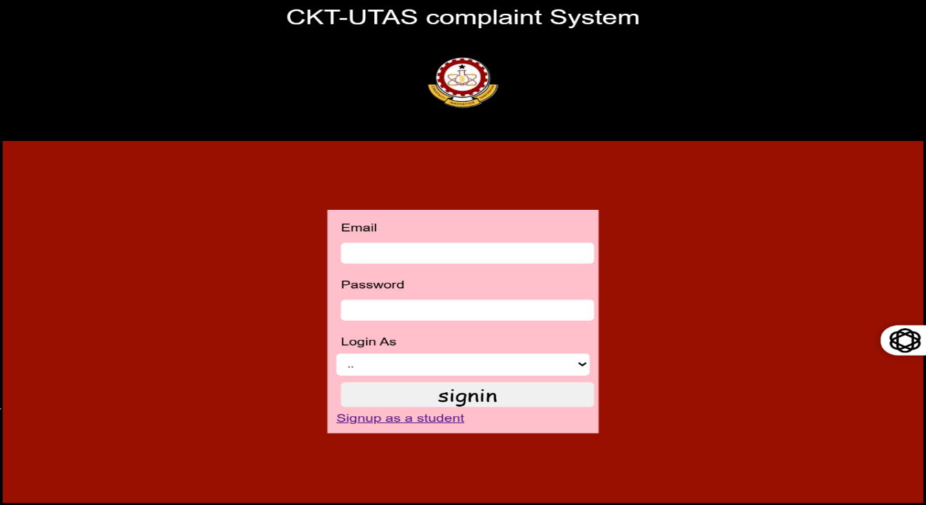
Figure 4.1 Login Page

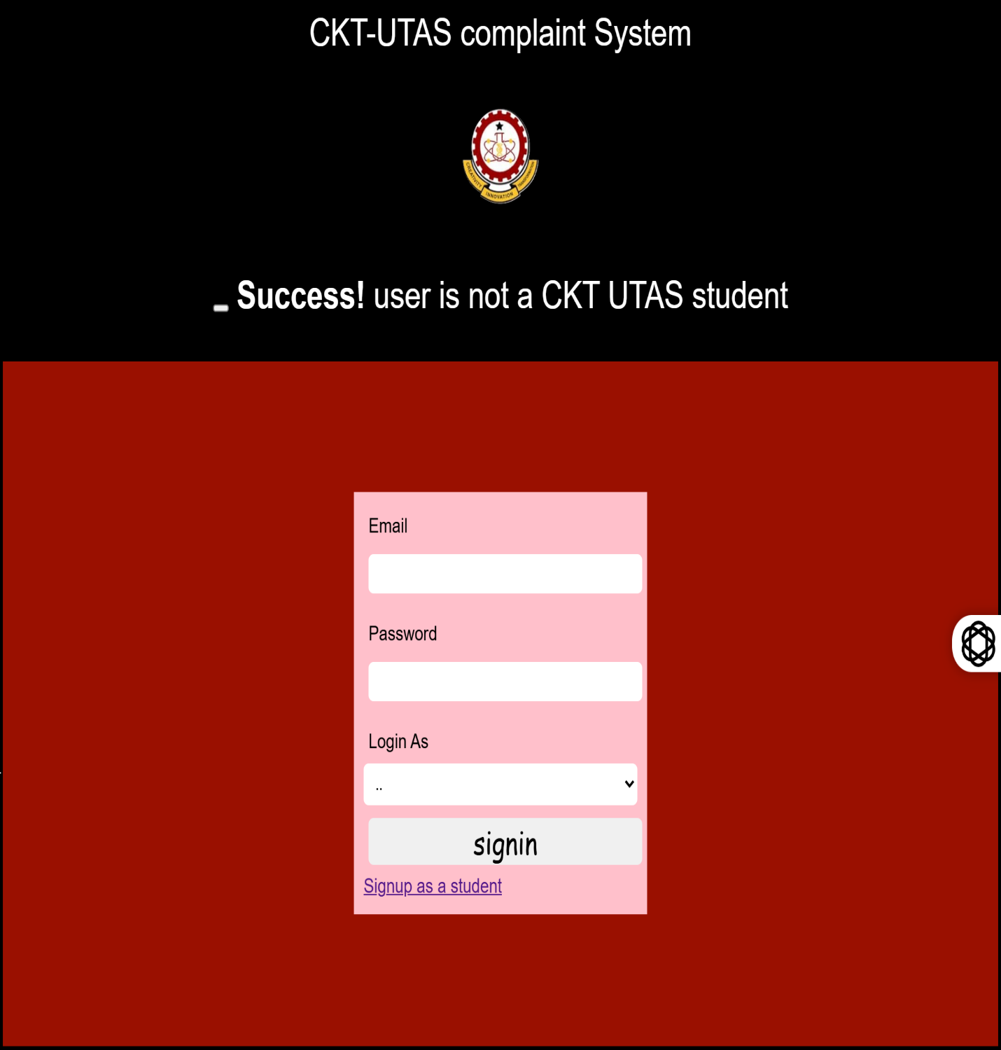

Figure 4.2 Access denial due to wrong credentials

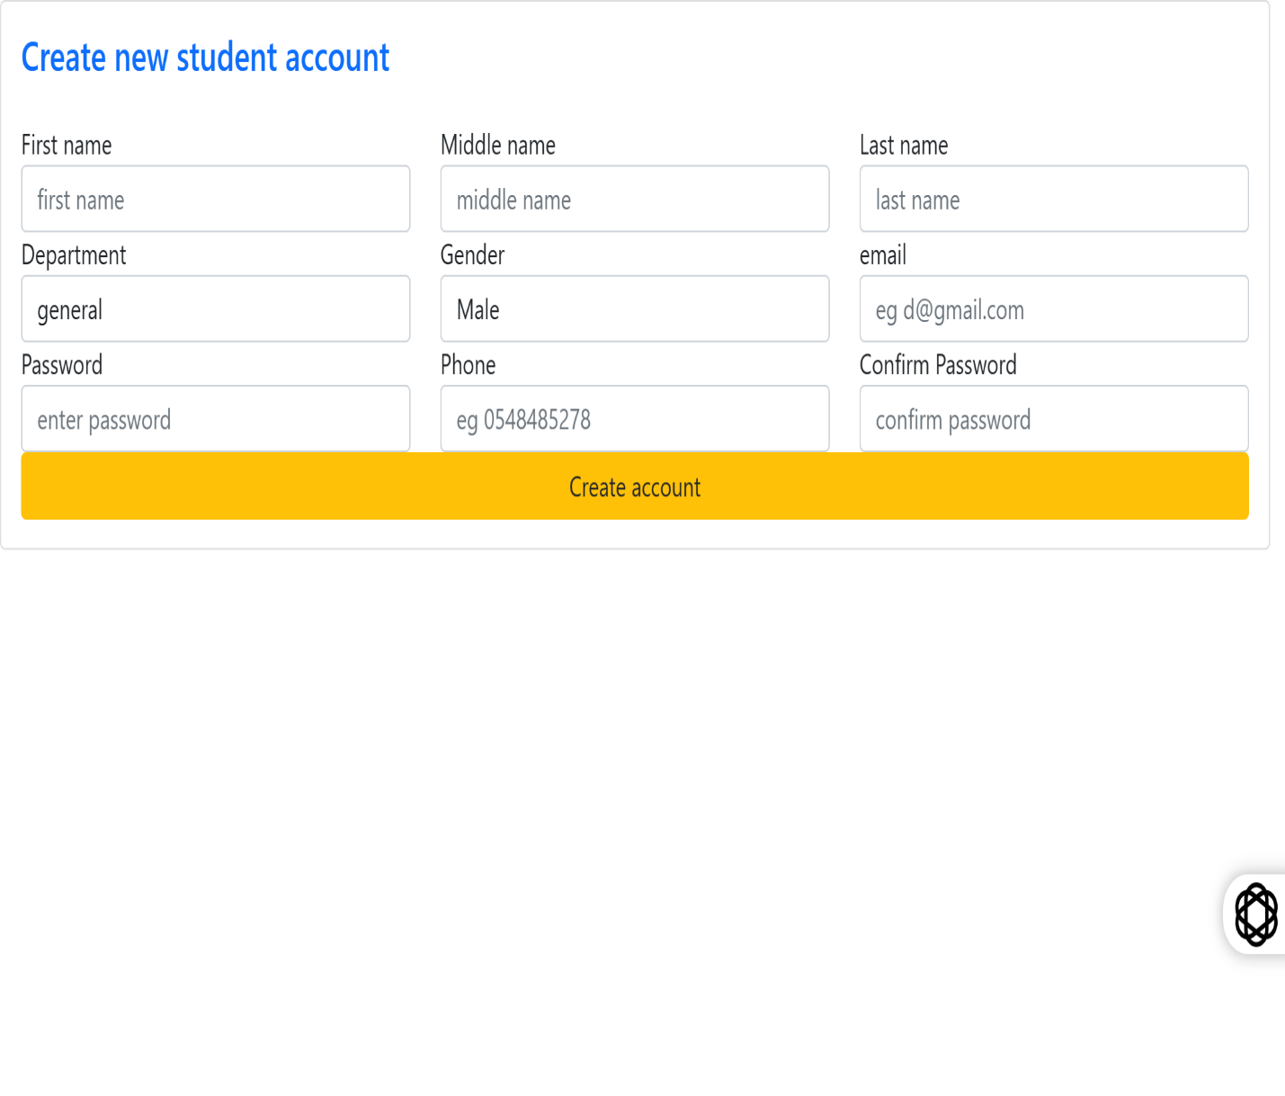
Figure 4.3 Student Signup Page

4.5.2 The Dashboard
This student complaint system has two dashboards for administrators and students respectively. Administrator dashboard only allows them to perform their duties as admins in the system. That is to view all complains lodged by students, to view those complains that are pending, in process and those that are processed. And also to be able to give student feedback on their complaints lodge. Student’s dashboard also allows students to only lodge complaints, view feedbacks from admins and track the status of their complaints lodged.
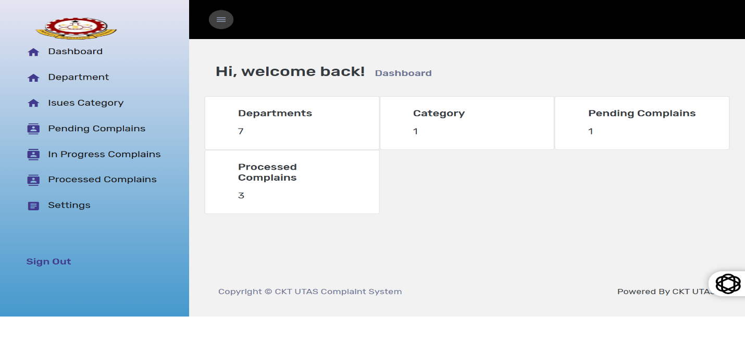
Figure 4.4 Admin dashboard
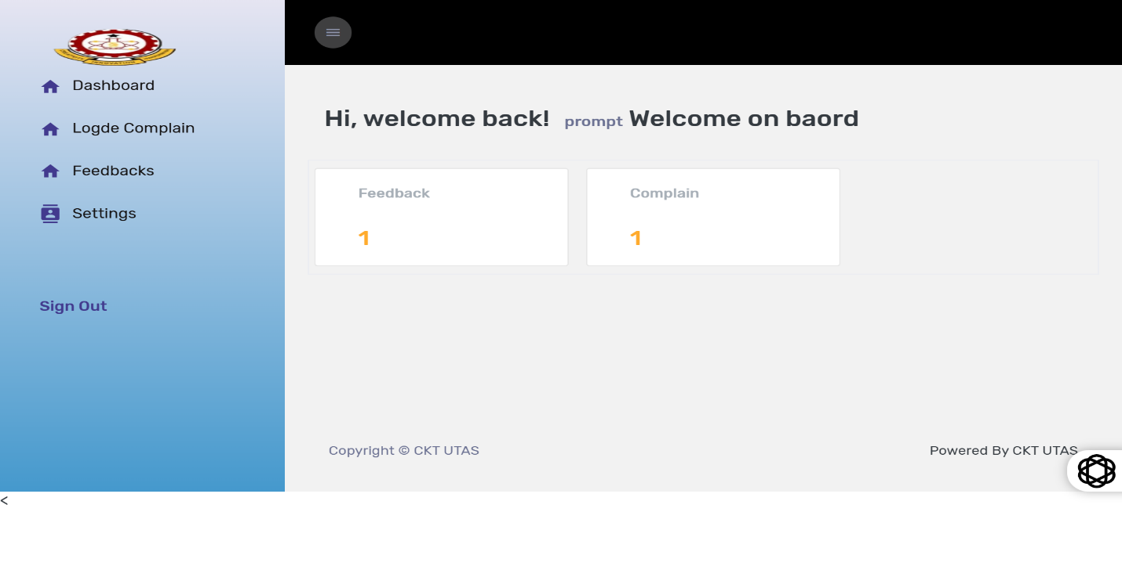
Figure 4.5 Student dashboard

4.5.3 Feedback to Complaints Lodged
This page displays all the complaints lodged by the particular student based on the login credentials and their status or the feedbacks from the system admins.
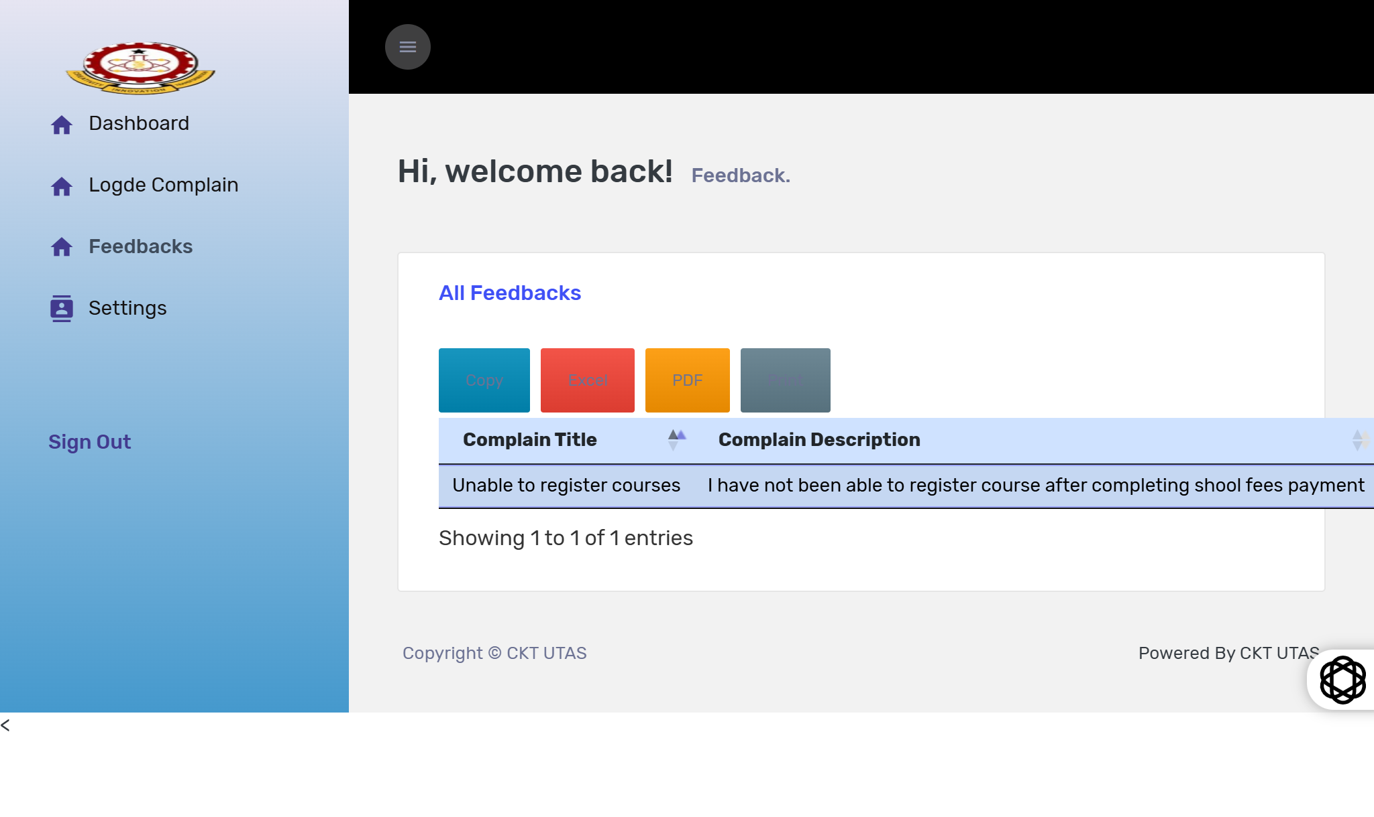
Figure 4.6 Feedback page
4.5.4 Settings Page
This is a page that allows both admins and students to make changes to their credentials. Either change their passwords, emails, personal details etc.
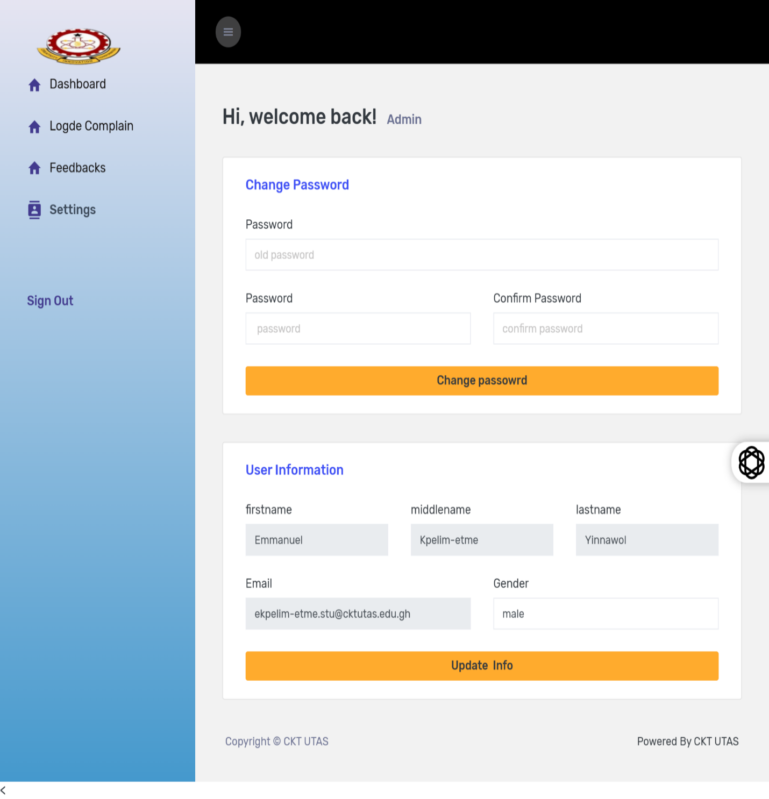
Figure 4.7 Settings page for students.

4.5.5 Department Page
This is a page that is only found on the admin side, which displays all departments registered in the system, where student’s complaints can be channeled to. It also allows the admins to add or register new departments into the system.
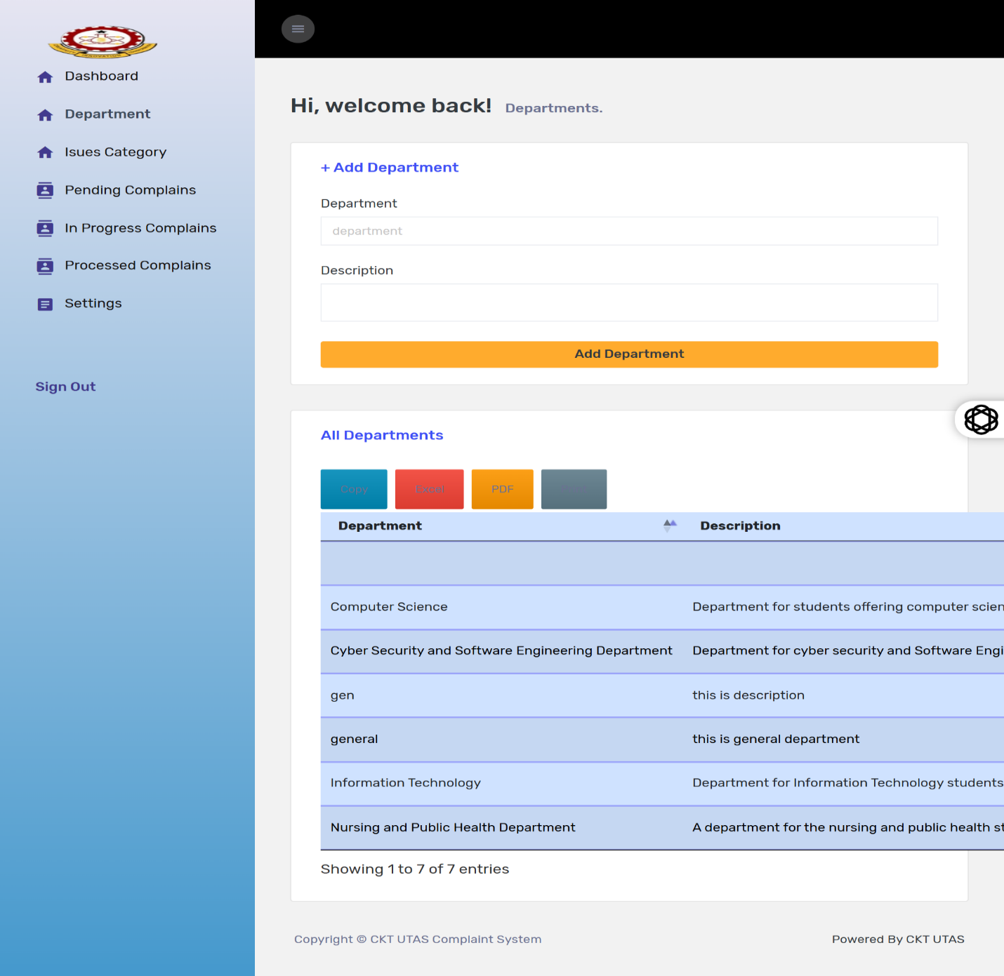
Figure 4.8 Departments page.

CHAPTER FIVE

SUMMARY, RECOMMENDATION AND CONCLUSION

5.0 Summary
The project “Design and Implementation of Student Complaint System for CKT-UTAS” was carried out to come up with a designed and implemented complaint system for CKT-UTAS specifically, with the primary objective of improving how complaints are reported, tracked and resolved.
Initially, students grievances were lodged primarily using the manual processes, which mostly led to longer response time, lack of transparency and no or poor record keeping. The said system became the solution to these problems by automating complaint submission through digitalization, providing real-time tracking, and giving both students and administrators an intuitive platform for resolution and communication. The system was built using mainly PHP programming language and MySQL in the backend as the database. PHP was considered the best for developing this system because of its easy syntax and features for developing a web-based application. The manual system for lodging complaints in the institution was studied and this new system has been designed to take care of the inefficiencies of the old system. Alongside with PHP and MySQL, HTML, CSS, Bootstrap, JavaScript were also used with XAMPP serving as the local development environment.
The system was able to undergo a successful testing, where students were allowed to log in, submit complaints, view their complaint status and track progress. Administrators on the other hand were able to manage these complaints, update statuses, and give feedbacks to students based on the complaints they have lodged. The adding of a role-based access control feature in the system ensured that different users were only authorized to access features relevant to their roles. The adoption of this system can significantly improve transparency, speed, and record-keeping in complaint handling (Agyemang & Gyan, 2021).

5.1 Conclusion
The importance of this student complaints system for this institution cannot be over looked. This project has proven to an effective tool for enhancing communication between students and administrators when it comes to grievances. It takes away non-required paperwork, minimizes delays in responding to complaints, and also makes complaint resolution process very transparent.
Embedding web technologies with a structured database, the system handles complaints appropriately with none been lost in any way or mishandled. Also, with the role-based access control added, it levels up the security of the system, guaranteeing the accessibility of confidential information to authorized individuals only.
However, the system is currently been deployed on a local environment and is fully functional, for the system to be used in the real-world application which in this case the institution, it will requirement an online deployment or deployment on the school server for accessibility to the respective users (Administrators and Students).

5.2 Recommendation
Since the primary goal of this whole system was to enable Students of CKT-UTAS lodge their complaints to the appropriate persons for resolution through a web-based system, which has been developed and tested and is approved. The below recommendations are made for enhancement and future improvements:
- Deployment to Live Server: In order for all students of the institution and administrators to make use of this system, there will be a need for individual installation on everyone’s machine which will be difficult to accomplish, therefore the need to host the application online or on the institution server for easy accessibility by all students and administrators.
- Mobile Platform Development: Producing an android or iOS version of the system will go a long way in improving accessibility by students, especially for those who prefer smartphone over desktop browsers. UNESCO (2021) advocates that digital educational tools have to be scalable and adaptable, to guarantee their use in multi- platforms and regions to increase inclusivity.
- Data Mining and Analytics: The management of data and identification of recurring issues is very important for early address of such issues proactively. Thus the implementation of statistics to complaints, charts, and automated trend analysis could help solve this problem.
- Vulnerability Management: Integrating two-factor authentication (2FA) and regular backups on database will help secure and protect against data breaches and accidental loss.
- Internationalization: This is to handle diverse student population; the system could adapt language selection features especially for foreign students who find themselves in the institution. It will help them express themselves freely whenever they have a complaint to lodge.

5.3. Limitations of the Study
Even though the project was able to meet its intended purpose, there were a few loop holes along the line, some of these are;
- The first is that, the tested got developed and tested on a local host, which in essence means that the ability of the system to withstand high traffic environment and its performance in the real-world has not yet been tested.
- The time for its development was not much as a lot of things had to be done alongside. And this led to me not being able to gather responses from students and administrators in order to help develop it.
- Again, due to time constraint, advanced features like AI-based complaint groupings, were not integrated into the system.
- The current functional user interface, could have further been enhanced for better accessibility on mobile devices.

REFERENCES
Agyemang, G., & Gyan, K. (2021). Manual versus digital complaint handling processes in higher education institutions. Journal of Education and Information Technology, 10(3), 44-52.
Al-Emran, M., & Shaalan, K. (2025). Digital transformation in higher education: A systematic review. Computers & Education, 210, 104788.
Alhassan, R., & Agyapong, K. (2022). Digital solutions for higher education administration in Ghana: Challenges and opportunities. International Journal of Education and Development Using ICT, 18(2), 115-129.
Burke, P.J. (2004). Access and equity in higher education: A critical perspective. Policy Futures in Education, 2(2), 225-236.
Casado-Diaz, A. B. (2009). Satisfaction merics in higher education support systems. Journal of Educational Research, 102(3), 227-240.
Coffield, F. (1995). A consumer complaint framework with resulting strategies: An application to higher education. Journal of Services Marketing, 8(3), 27-39. https://doi.org/10.1108/08876049410065598
Jackson, C. (2009). Technology adoption in higher education institutions. Journal of Higher Education Policy and Management, 31(3), 229-239.
Johnson, L., Becker, S., Cummins, M., & Estrada, V. (2016). Technology outlook for higher education 2016-2021: An NMC Horizon Project sector analysis. New Media Consortium. Retrieved from https://files.eric.ed.gov/fulltext/ED595119.pdf
Kassem, R., & Dahab, M. (2018). Web-based grievance management systems: A review. International Journal of Computer Applications, 179(12), 15-22.
Mann, S. J. (2001). Alternative perspectives on the student experience: Alienation and engagement. Studies in Higher Education, 26(1), 7-19. https://doi.org/10.1080/03075070020030689
Millward, L. J. (2015). Institutional support services: A framework for improvement. Higher Education Quarterly, 69(3), 212-229.
Mohammed, A.,Solomon, S. N., & Nurideen, M. (2021). Designing a web-based complaint management system for Sunyani Technical University. Ghana Journal of Technology, 6(2), 55-65.
Moshaq, A. (2013). Philosophy of science and research methodology. Moscow: Progress Publisher.
Phratama, Y. (2024). Implementing mobile-first complaint systems in Indonesian polytechnics. Journal of Educational Technology Research, 18(1), 45-61’
Pressman, R. S., & Maxim, B. R. (2020). Software engineering: A practitioner’s approach (9th Ed.). New York, NY: McGraw-Hill.
Rolfe,G. (2002). Reflective practice: Where now? Nurse Education in Practice, 2(1), 21-29. https://doi.org/10.1054/nepr.2002.0047
Schoefer, K. (2008). Service recovery in higher education institutions. Journal of Marketing in Higher, 18(20, 145-164.
Scott, J. (2018). Real-time communication in academic complaint systems. Computers in Human Behavior, 89, 317-324.
Sommerville, I. (2016). Software engineering (10th Ed.). London: Pearson Education.
Tshotlego, M. (2024). Complaint systems in rural Botswana colleges: Challenges and opportunites. African Journal of Higher Education Policy, 12(1), 88-104.
UNESCO. (2021). The digital transformation of education: Global report. Paris: UNESCO Publishing.
Welling, L., & Thomson, L. (2017). PHP and MySQL web development (5th ed.). Botson, MA: Addison-Wesley.
Yilmaz, R. (2020). Exploring the role of user experience in web-based educational systems. Interactive Learning Environments, 28(6), 745-761.

APPENDICES

Appendix A: Database Connection and Initialization
This code creates the connection for the database and initializes the application environment. It is needed across multiple modules to grant constant access to the MySQL database.
<?php
ob_start();
session_start();
date_default_timezone_set("Africa/Accra");

// Database connection
$server = "localhost";
$user = "root";
$pass = "";
$db = "cms";

$conn = mysqli_connect($server, $user, $pass, $db);

if(!$conn){
die("Connection failed: " . mysqli_connect_error());
}
?>

Appendix B: Complaint Submission Module
The below codes are responsible for enabling students to submit new complaints into the complaint system. It verifies inputs, inserts data into the database, and confirms submission.

<?php
Require_once ‘../dist/inc/init.php’;

If (isset($_POST[‘submit’])) {
$subject = mysqli_real_escape_string($conn, $_POST[‘subject’]);
$complain = mysqli_real_escape_string($conn, $_POST[‘complain’]);
$userid = $_SESSION[‘USER’][‘id’];

$sql = “INSERT INTO complaints_table (user_id, subject, complaint, status, created_at)
VALUES (‘$userid’,’$subject’,’$complain’,’Pending’, NOW())”;

If (mysqli_query($conn, $sql)) {
Echo “<script>alert(‘Complaint submitted successfully’);</script>”;
} else {
Echo “Error: “ . mysqli_error($conn);
}
}
?>

Appendix C: Complaint viewing Module
A module that retrieves all complaints submitted by logged-in student and shows them a table format.

<?php
Require_once ‘../dist/inc/init.php’;
$userid = $_SESSION[‘USER’][‘id’];

$sql = “SELECT * FROM complaints_table WHERE user_id=’$userid’ ORDER BY created_at DESC”;
$result = mysqli_query($conn, $sql);

While ($row = mysqli_fetch_assoc($result)) {
Echo “<tr>
<td>{$row[‘subject’]}</td>
<td>{$row[‘complaint’]}</td>
<td>{$row[‘status’]}</td>
<td>{$row[‘created_at’]}</td>
</tr>”;
}
?>

Appendix D: User profile and Setting
Codes allows students to update their personal information, such as password or profile details.

<?php
Require_once ‘../dist/inc/init.php’;

If (isset($_POST[‘update’])) {
$userid = $_SESSION[‘USER’][‘id’];
$fullname = mysqli_real_escape_string($conn, $_POST[‘fullname’]);
$password = mysqli_real_escape_string($conn, $_POST[‘password’]);

$sql = “UPDATE users_table SET fullname=’$fullname’, password=’$password’ WHERE id=’$userid’”;
If (mysqli_query($conn, $sql)) {
Echo “<script>alert(‘Profile updated successfully’);</script>”;
}
}
?>

Appendix E: Feedback and Dashboard Modules
E.1: Student Dashboard
This shows the summary of student complaints and system notification

<?php
Require_once ‘../dist/inc/init.php’;
$userid = $_SESSION[‘USER’][‘id’];

$sql = “SELECT COUNT(*) AS total FROM complaints_table WHERE user_id=’$userid’”;
$result = mysqli_query($conn, $sql);
$data = mysqli_fetch_assoc($result);
Echo “Total Complaints: “ . $data[‘total’];
?>

E.2: Student Feedback Submission
Permits students to send feedback or suggestions to administrators.
<?php
Require_once ‘../dist/inc/init.php’;
If (isset($_POST[‘submit’])) {
$userid = $_SESSION[‘USER’][‘id’];
$message = mysqli_real_escape_string($conn, $_POST[‘message’]);
$sql = “INSERT INTO feedback_table (user_id, message, created_at) VALUES (‘$userid’,’$message’,NOW())”;
If (mysqli_query($conn, $sql)) {
Echo “<script>alert(‘Feedback sent successfully’);</script>”;
}
}
?>

E.3: Admin Feedback Management
Allows administrators to view, respond to, and manage student feedback.
<?php
Require_once ‘../dist/inc/init.php’;
$sql = “SELECT f.*, u.fullname FROM feedback_table f
JOIN users_table u ON f.user_id=u.id ORDER BY f.created_at DESC”;
$result = mysqli_query($conn, $sql);

While ($row = mysqli_fetch_assoc($result)) {
Echo “<tr>
<td>{$row[‘fullname’]}</td>
<td>{$row[‘message’]}</td>
<td>{$row[‘created_at’]}</td>
</tr>”;
}
?>

E.4: Feedback Processing Endpoint
Controls admin action on student feedback, such as sending SMS/email notifications.
<?php
Require_once ‘../../dist/inc/init.php’;

If (isset($_POST[‘send’])) {
$userid = $_POST[‘userid’];
$reply = mysqli_real_escape_string($conn, $_POST[‘reply’]);

$sql = “UPDATE feedback_table SET reply=’$reply’, reply_date=NOW() WHERE user_id=’$userid’”;
Mysqli_query($conn, $sql);

// Example SMS API integration (pseudo-code)
$phone = “+233XXXXXXXXX”;
$msg = “Your feedback has been reviewed. Admin reply: $reply”;
File_get_contents(https://sms-api.example.com/send?to=$phone&msg=$msg);
}
?>

